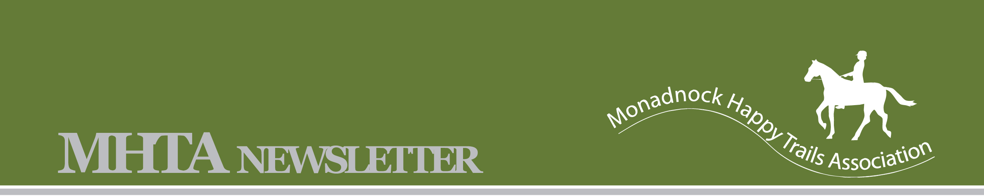
January 2009

Monadnock Happy Trails Association

Meets: First Wednesday of each Month at the Swanzey Public Library, Route 32, Swanzey Center, NH
www.mhta.synthasite.com

MHTA Board
President: John Whitney: whitneysminis@verizon.net
Vice Pres: Sharon Thomsen: animalover00xx@yahoo.com
Treasurer: Brian Hickey: hicks@cheshire.net
Secretary: Barbara Kahn: rubikahn@yahoo.com
Newsletter: Krys Swan: ksd_zine@yahoo.com

January 2009 Meeting Highlights
The club held its first meeting of 2009 at the Mount Caesar Library on Wednesday, January 14th. Our speaker was Beth Phippard.
• Beth gave a very informative and detailed talk on camping with your horse. Beth has camped in numerous places and is an excellent source of information. She gave us quite a checklist of necessities, precautions and provisions. One thing that those of us at the meeting agreed that we would not have thought of is ascertaining the availability of a vet and farrier before going on a particular ride.
Thank you very much, Beth, we all enjoyed learning from you and appreciate the work involved in putting your presentation together.
• Another thing that we realized was how helpful it was to have a resource to give opinions and advice about the different rides. Perhaps it would be beneficial to have members report on the different rides they've done and compile a travel-log of our own. We could give the rides a "5 horseshoe rating" or a "ears forward, ears back" decision. Please come to the next meeting with a ride report of your own to share.

• Email Krys Swan at KSd_zine@yahoo.com with ideas for the website and newsletters. There were suggestions of new pages to add in the October Newsletter but I did not receive any information. The travel log suggested in the meeting is a great idea for the website. We can have a section for club rides and a section for non-club rides. There are areas in my town that have great riding but not enough parking to host a ride. So reporting that a place was “ears forward” gives other members the option to try new places on their own.

• Visit us at www.mhta.synthasite.com
• Reminder to all members: Remember to send in your membership renewal. It is time to start thinking about new board members. Please come to the next meeting if you are interested.



Trail Tip of the Month: If you plan to ride, and the ground is slippery ask your farrier about shoes with pads and ice studs. If you do not use snow pads give the bottom of hooves a coating of petroleum jelly to prevent snowballs forming in hooves while you ride

